**Team ID:PNT2022TMID45531**

**Project Report Format**

**1. INTRODUCTION:**

**1.1 Project Overview**

Whenever a job seeker applies for a Nutrition Assistant role in a new company, he/she must signal their value through multiple mediums. While the Nutrition Assistant resume will be the most well-known part of the Nutrition Assistant job application, but, do consider the Nutrition Assistant cover letter equally important for landing a job. Writing a great Nutrition Assistant cover letter plays an important role in your [job search](https://www.naukri.com/) journey.

Many employers no longer ask for cover letters these days, whereas, many employers still ask for cover letters from job seekers. And if you are sending an email to the recruiting team to apply, your email itself acts as a cover letter.

**1.2 Purpose**

Nutrition assistants help dieticians with providing proper nutrition at healthcare facilities. They determine patients' nutritional needs, assess risk factors, and plan meals and menus. They also ensure proper sterilization of plates and utensils.

* Associate’s degree in nutrition or a related field
* Certification as a dietetic technician is preferred
* Previous experience in a similar role is preferred
* Ability to provide high-quality dietary advice to patients
* Willingness to customize dietary advice to meet the unique needs of patients
* Excellent interpersonal skills

**2. LITERATURE SURVEY**

**2.1 Existing Problem**

Nutrient deficiencies are prevalent worldwide. Diseases and morbid conditions have been described to result from nutritional deficiencies. It is essential to address nutrient deficiencies as these may lead to chronic long-term health problems such as rickets, iron deficiency anemia, goiter, obesity, coronary heart disease, type 2 diabetes, stroke, cancer and osteoporosis. In the present review we surveyed the extent and severity of nutritional deficiencies in Israel through a selective and comprehensive Medline review of previous reports and studies performed during the last 40 years. Israeli populations have multiple nutritional deficiencies, including iron, calcium, zinc, folic acid, and vitamins B12, C, D and E, spanning all age groups, several minorities, and specific regions.

**2.2 Proposed solution**:

  we are  developed web application to take a picture of the food that is being served, the picture is stored in internal memory and automatically applied to the module. And that model is capable of predicting the kind of food image. after that the predicted output will be match to the dataset of composition of food nutrients. The output will be displayed as composition of all the nutrients present inside the particular food. on the web and mobile application's display once the process is complete.so, any people know the type nutrients and its composition  of the food.

**3. THEORITICAL ANALYSIS**

Technological solutions provided to customers with the aim of nutritional information, could be a major challenge of interaction amongst caterers and customers. The purpose of this paper is to evaluate an electronic intelligent system of personalised dietary advice (called 'DISYS') for tablets and smartphones. This application provides nutritional analysis of menu items and personalised suggestions according to the nutritional demands of each customer. The DISYS application was characterised as an easy-to-use, comprehensive and useful tool. Volunteers consider that this application contributes to overall health by enabling the modulation of body weight throughout healthier choices, reduction of calorie intake and self-monitoring. Application of mHealth as such, designed to provide nutritional information, seems to be useful for customers as they recommend appropriate nutritional options. They seem also to be an effective tool for caterers and nutritionists, who can provide value-added service.

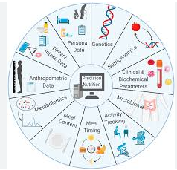

**3.1 Block Diagram:**

















**3.2 Ideation**

**Hardware:**

No Hardware is required for this project.

**Software:**

* There is only one web application needed.
* For application deployment, we use Red Hat OpenShift and docker-file.
* We use Virtual Studio code for writing the code.

**4. EXPERIMENTAL INVESTIGATIONS:**

[Vitamin deficiencies](https://www.sciencedirect.com/topics/medicine-and-dentistry/hypovitaminosis" \o "Learn more about Vitamin deficiencies from ScienceDirect's AI-generated Topic Pages) remain common globally. Unless severe, they are often clinically unrecognized, yet even mild deficiency may have significant adverse consequences. Vitamin deficiencies affect all ages and frequently co-exist with mineral (zinc, iron, iodine) deficiencies. The groups most susceptible to vitamin deficiencies are pregnant and lactating women, and young children, because of their relatively high needs for these compounds and susceptibilities to their absence. These include death from infectious diseases, anemia, death during pregnancy or [childbirth](https://www.sciencedirect.com/topics/medicine-and-dentistry/childbirth" \o "Learn more about childbirth from ScienceDirect's AI-generated Topic Pages) and impaired cognition and physical development. The effects of vitamin deficiencies are related to the biochemical roles they play. Some of the most common deficiencies relate to [vitamin A](https://www.sciencedirect.com/topics/medicine-and-dentistry/retinol" \o "Learn more about vitamin A from ScienceDirect's AI-generated Topic Pages), various B vitamins, [folate](https://www.sciencedirect.com/topics/medicine-and-dentistry/folic-acid" \o "Learn more about folate from ScienceDirect's AI-generated Topic Pages) and vitamin D. Supplementation programs have made diseases such as scurvy (vitamin C deficiency) or [pellagra](https://www.sciencedirect.com/topics/medicine-and-dentistry/pellagra" \o "Learn more about pellagra from ScienceDirect's AI-generated Topic Pages) (niacin deficiency) rare. New information suggests that [vitamin D deficiency](https://www.sciencedirect.com/topics/medicine-and-dentistry/vitamin-d-deficiency" \o "Learn more about vitamin D deficiency from ScienceDirect's AI-generated Topic Pages), which causes [osteomalacia](https://www.sciencedirect.com/topics/medicine-and-dentistry/osteomalacia" \o "Learn more about osteomalacia from ScienceDirect's AI-generated Topic Pages) and [rickets](https://www.sciencedirect.com/topics/medicine-and-dentistry/rickets" \o "Learn more about rickets from ScienceDirect's AI-generated Topic Pages), is associated with abnormal immunoregulation and infectious diseases. Table 139-1 lists the most important consequences of deficiency and the recommended dietary intakes for the vitamins discussed in this chapter.

Therefore, we have made the decision to create a user-friendly device. to assist folks who do not know the nutritional value of the food while they are purchasing. They buy food accordingly to their nutrient needs. In the field of medical, the equipment is quite beneficial.

By using the developed web application to take a picture of the food that is being served, the picture is stored in internal memory and automatically applied to the module. And that model is capable of predicting the kind of food image. after that the predicted output will be match to the dataset of composition of food nutrients. The output will be displayed as composition of all the nutrients present inside the particular food. on the web and mobile application's display once the process is complete.so, any people know the type nutrients and its composition  of the food.

**5. FLOW CHART:**

**INPUT**



(THIS APPLICATION (GADGET) IS CAPTURE THE FOOD OF IMAGE WITH THE HELP OF CAMERA.)



(WE HAVE A CREATED ONE MODULE USING MACHINE LEARNING WITH PYTHON AND DATASET OF IMAGE . THAT MODULE HELP TO IDENTIFY THE CATEGORY (IMAGE) OF THE FOOD .)



(WE HAVE ALSO CREATED ANOTHER DATASET OF THE NUTRIENTS.THE OUTPUT OF THE MODULE IS MATCHING THE DATASET OF THE NUTRIENTS WITH THE HELP OF THAT DATASET THE FINAL OUTPUT DISPLAY.)





( IN TABLE FORMATE LIST OF THE COMPOSITION AND TYPE OF THE NUTRIENTS ID DISPLAY ON THE SCREEN.)

**6. RESULT**

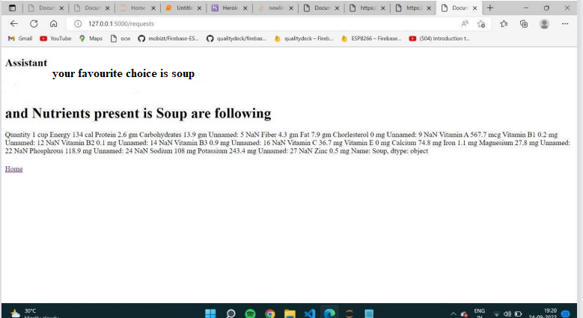

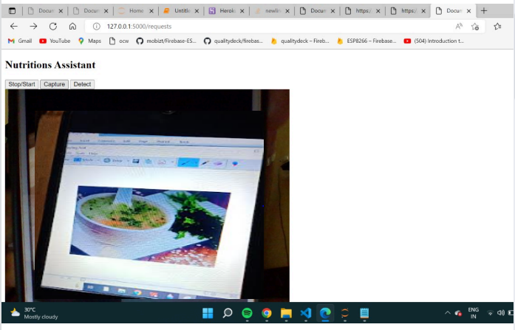

**7. ADVANTAGES AND DISADVANTAGES**

**Advantages:**

* This device is user friendly.
* Its only required the image of the  food.
* To know the different type of nutrients present in food .
* And also know that how much composition of the nutrients are present.
* Output of the screen is easy understandable.

**Disadvantages:**

* + - This device is not able to predict the multiple image as input.
    - The internet is only necessary for opening the web application.(After converting the mobile app internet is not necessary for opening .)

8. APPLICATIONS:

Any food production firm can use this technology to verify the ingredients after utilizing it to determine the components and nutrients present in each food item. The company can then simply print the ingredients on the food package. This technique cuts down on the time needed to identify substances.

It is also useful assists folks who do not know the nutritional value of the food while they are purchasing. They buy food accordingly to their nutrient needs. In the field of medical world, the equipment is quite beneficial.

9. CONCLUSION

During this assignment we were able to take a closer look at our daily eating habits. From here we can now improve our application so that we can help clients to eat and grow healthier as a person and athleteI can truly say that I learnt a lot from this assignment. I was able to point out changes I needed to make and how to move forward and make it work in my life. I am now more educated on the powers of food and how they control our body. I hope that people will use our application to lead a healthy life. When choosing the right foods for yourself you should be focused on what is the healthiest choice. Eating healthy and feeling good go hand in hand , eating better will automatically give you a better functioning body.

We would recommend our application to anyone who is interested in eating healthy. Not only is it easy to use, but it is a great way to evaluate what you are eating and understand the vitamins and minerals that you need.

10. FUTURE SCOPE

The device will also assist you determine the quantity and degree of flavour of the food.

Future goals include increasing the accuracy of our machine learning model and expanding the types of food categories so that we can better meet user needs.

We are also increasing dataset of categories of images and nutrition to better efficiency to get output.

Our research essentially identifies simply the nutrients, but our team members raise the bar for our project so that we also understand the ingredients and the amount of nutrients in a particular cuisine.

According to CBS News large study, poor diet is associated with 1 in 5 deaths worldwide which is equivalent to 11 million deaths a year that makes unhealthy eating habits responsible for more deaths than tobacco and high blood pressure. People need to control their daily nutritional intake by eating healthier foods which is the most basic method to avoid these risks.

11. BIBILOGRAPHY

<https://www.who.int/news-room/fact-sheets/detail/food-safety>

[https://www.fssai.gov.in/cms/food-safety-and-standards-rules-- 2011.php](https://www.fssai.gov.in/cms/food-safety-and-standards-rules--%202011.php)

<https://www.foodsafety.gov/keep-food-safe/food-safety-by-typefood>

<https://www.foodsafety.gov/keep-food-safe/food-safety-by-typefood>

<https://www.foodsafety.gov/keep-food-safe/food-safety-by-typefood>

<http://government.ru/en/department/59/events/>

https://www.redhat.com/en/services/training/do080- deploying-containerized-applications-technical-overview

https://www.open.edu/openlearncreate/mod/ouconten t/view.php?id=315&printable

<https://www.academy.alimentarium.org>

<https://en.wikipedia.org/wiki/Food_safety>

<http://government.ru/en/department/59/events/>

<https://cognitiveclass.ai/search?q=cloudant+dc>

<https://www.youtube.com/c/thesmartbridge>

APPENDIX

Source code:

GITHUB &PROJECT DEMO LINK

